

**INTRODUCTION**

* 1. **Project Summary**
  2. **Purpose**
  3. **Scope**
  4. **Technology and LiteratureReview**



# PROJECT SUMMARY

Client Relationship Management System (CRM) Interactive, customized experience, companies have a greater ability today to establish nurture and long-term customer relationship than ever before. the ultimate goal is to transform this relationship into greater profitability by increasing repeat purchase rates and reducing customer acquisition costs. Indeed, this revolution in customer relationship management. Through this application track customer behavior on the web to predicting their future moves to sending direct email communication.

# PURPOSE

This Web Application provides CRM is a system that helps businesses manage relationships and interactions with customers.

Client Relationship Management System helps aims to build a platform where customers, sales representatives, and administrators can easily communicate and handle different parts of the business. Customers can sign up, get project estimates, share their ideas, track project progress, and see available deals. Sales representatives can invite customers, collect feedback, arrange meetings, and help with any customer questions. The admin takes care of user management, reviews, customer relationships, and provides reports for smarter business decisions.



# SCOPE

***Client Relationship Management System***  involves creating an application aimed at facilitating interactions between customers, business development executives (BDEs), and administrators within a company.

For customers, the application provides several key functionalities. They can register and log in, allowing them access to the system's features. They can receive estimates related to projects, share their own ideas, track the status of their projects, and leave reviews. Additionally, they can access information about deals with the company.

BDEs, on the other hand, have specific tasks tailored to their role. They can use the application to invite customers via email, gather feedback, schedule discussions, and address customer queries. Like customers, they can also register and log in.

The administrator has overarching control over the system. They can manage all users, review customer feedback, assess the relationship between customers and the company, and access reports detailing customer relationships.

Overall, the application serves as a platform for seamless communication and interaction between customers, BDEs, and administrators, streamlining processes and enhancing customer-company relationships.



# TECHNOLOGY AND LITERATURE REVIEW

**EXISTING SYSTEM**

Customers can register and log in, receive project estimations, share their thoughts, track their project's progress and reviews, and access deals information.

BDEs can invite customers via email, collect feedback, arrange discussions, and resolve queries. They also have access to login/register on the application.

The admin oversees user management, customer reviews, and the overall relationship between customers and the company. They can analyze customer relationships and access reports based on customer interactions.



.

**PROPOSEDSYSTEM**

The proposed system is a Client Relationship Management (CRM) platform where customers, BDEs, and an admin can interact. Customers can register, get project estimations, share thoughts, track project status and reviews, and access deals information. BDEs can invite customers via email, gather feedback, arrange discussions, and resolve queries. They can also register on the platform. The admin manages users, reviews, and oversees the customer-company relationship. They analyze customer interactions and access relationship reports.



**Chapter No: 2**

**SYSTEM REQUIREMENT STUDY**

* 1. **User Characteristics**
  2. **Hardware& Software Requirement**



# USER CHARACTERISTICS

In this system there are three users:

1. Admin
2. Customers

**Task of Administrator:**

* Managing all users within the system.
* Viewing all customer reviews for insights and improvement.
* Assessing and enhancing the customer-company relationship.
* Generating and reviewing customer-wise reports to understand relationship dynamics.

**Task of BDE:**

* Inviting customers via email.
* Gathering customer feedback.
* Arranging discussions with customers.
* Resolving customer queries.
* Logging in/registering on the application.

**Task of Customers:**

* Registering and logging in to the application.
* Receiving project estimations.
* Providing personal input.
* Viewing the status and review of their developed system.
* Accessing all deals information with the company.



* + Give Examination
  + View result Online
  + give comments & view report

# HARDWARE& SOFTWARE REQUIREMENTS

**Server Configuration**

* + - PC
    - 4GB RAM
    - Minimum 3GB free space of HDD

**Client Configuration**

* + - PC
    - 4GB RAM

**Software Requirement**

* + - Eclipse IDE
    - SQL



**Chapter No: 3 SYSTEM ANALYSIS**

* 1. **Problem Definition**
  2. **Fact Finding Technique**
  3. **NeedFor Computerization**
  4. **Process Model**
  5. **Requirement Analysis**
  6. **Feasibility Study**
  7. **Requirement Validation**
  8. **Study of current version**
  9. **Problem and weakness of current system**
  10. **Requirement of new system**



# PROBLEM DEFINATION

**WHAT IS THE PROBLEM?**

# The problem we're solving is creating a system that helps customers, BDEs, and an administrator communicate better. Customers want to register, get project estimates, share feedback, track project progress, and see company deals. BDEs need tools to invite customers, gather feedback, arrange discussions, and solve problems. The administrator manages users, reviews feedback, improves customer-company relationships, and generates reports. Our goal is to make a system that makes communication and relationship management between the company and its customers smoother.

# FACT FINDING TECHNIQUE

# fact-finding technique for involves gathering information about the needs and requirements of customers, BDEs, and the administrator. This includes understanding what features they need in the system, how they interact with it, and what problems they encounter. Through methods like interviews, surveys, and observation, we aim to uncover insights into their workflows, preferences, and pain points. This helps us design a system that effectively meets their needs and improves communication and management processes within the company.



# FACT FINDING TECHNIQUE

The client relationship management system is designed to make interactions between customers and the company smoother. Customers can register and log in to access project estimates, share their thoughts, track project progress, and review their experiences. Business Development Executives (BDEs) reach out to customers via email, gather feedback, schedule discussions, and address queries. Administrators oversee user management, review customer feedback, analyze customer relationships, and access customer-specific reports. Overall, the system aims to enhance communication and provide insights into customer satisfaction.

this system like a friendly assistant that helps both customers and the company work together better. Customers can sign up and use the system to see how their projects are going, share their ideas, and tell the company what they think about their experience. Meanwhile, the company's team members, like the Business Development Executives (BDEs), can use the system to talk to customers, ask for their feedback, and make sure everything is going smoothly. And behind the scenes, administrators are like the managers who keep everything organized, making sure everyone has what they need and can see how well the company is doing with each customer. It's all about making things easy and keeping everyone happy!



# NEED FOR COMPUTERIZATION

company deals with many customers, each having their own projects and needs. Before computerization, managing all these interactions would be quite a challenge. Customers would have to visit the company physically or communicate through phone calls or emails, which can be time-consuming and prone to errors. Similarly, Business Development Executives (BDEs) would have to manually handle customer invitations, feedback collection, scheduling discussions, and resolving queries, leading to inefficiencies and potential misunderstandings.

For administrators, managing user accounts, reviewing customer feedback, analyzing customer relationships, and generating reports would be a cumbersome task if done manually. It would require maintaining piles of paperwork and spreadsheets, increasing the likelihood of data errors and making it difficult to track the overall performance of the company's relationships with its customers.

Computerization brings a solution to these challenges by introducing a client relationship management system. This system allows customers to register and log in to an application where they can access project estimations, provide feedback, track project status, review their experiences, and view deal information, all in one centralized platform. This streamlines the customer experience, making it easier for them to interact with the company and stay updated on their projects

For BDEs, the system automates tasks such as sending customer invitations, collecting feedback, scheduling discussions, and resolving queries. This not only saves time but also ensures that all interactions are recorded and tracked systematically, leading to better communication and customer satisfaction.

Administrators benefit from the system by having a centralized platform to manage user accounts, review customer feedback, analyze relationships with customers, and generate reports. This enables them to efficiently monitor and assess the company's overall performance in managing customer relationships, identify areas for improvement, and make data-driven decisions to enhance customer satisfaction and loyalty.



# PROCESS MODEL

The process model is a core diagram in structured analysis and design.Each process transforms inputs into outputs.

The model generally starts with a context diagram showing the system as a single process connected to external entities outside of the system boundary. This process explodes to a lower level DFD that divides the system into smaller parts and balances the flow of

information between parent expresses a complex system.

and child diagrams. Many diagram levels may be needed to



**3.6 Requirement Analysis**

**Customer Module:**

**Customers should be able to register and log in to the application. They should have access to project estimations, be able to submit their own thoughts or requirements, view the status of their projects, provide feedback, and access information about deals with the company.**

**Business Development Executive (BDE) Module:**

**BDEs should have the capability to invite customers via email, collect feedback, arrange discussions, resolve customer queries, and have login access to the application.**

**Admin Module:**

**Administrators should have the authority to manage all users, view customer reviews, analyze customer relationships, and generate reports on customer interactions.**

.

# 3.7 FEASIBILITY STUDY



The feasibility analysis tests are basically of four types as follows:

1. Operational feasibility
2. Technical feasibility
3. Schedule feasibility
4. Economic feasibility

Firstly, we evaluate the technical feasibility. This includes examining whether the technology

required for the CRM system is readily available and can be effectively implemented. We will

need to ensure that the necessary software and hardware are accessible and compatible with the

project's requirements.

Next, we consider the economic feasibility. This involves analyzing the costs associated with

developing and maintaining the CRM system compared to the benefits it will provide. We need

to determine if the investment in the CRM system is financially sound and if the expected

returns justify the expenses.

Thirdly, we assess the operational feasibility. This entails examining how the CRM system will

integrate with existing business processes and whether it will improve efficiency and

productivity. We need to ensure that the system will be user-friendly and that employees will

be able to adapt to it easily.

Lastly, we evaluate the schedule feasibility. This involves determining whether the project can

be completed within the specified time frame. We need to consider factors such as resource

availability, project complexity, and potential risks that could delay the implementation of the CRM system.

By conducting a comprehensive feasibility study, we can determine whether the client relationship management project is viable and worth pursuing.



1. **Operational feasibility**

Operational feasibility assesses whether the proposed client relationship management (CRM) system aligns

with the organization's existing operations and processes, and whether it can be effectively integrated into

daily activities.

This involves examining how the CRM system will impact day-to-day tasks, workflows, and employee

responsibilities. It's crucial to ensure that the system enhances efficiency, rather than disrupts it. For

example, if the CRM system requires extensive training or significantly alters established workflows, it may

face resistance from employees and hinder adoption.

Operational feasibility also considers the system's scalability and flexibility. As the organization grows and

evolves, the CRM system should be able to accommodate changes in business needs and adapt

accordingly. Additionally, it's important to assess whether the organization has the necessary resources,

such as skilled personnel and technical support, to implement and maintain the CRM system effectively.

By evaluating operational feasibility, we can determine whether the proposed CRM system will effectively

support the organization's operations and contribute to its overall success.



1. **Technical Feasibility:**

technical feasibility evaluates whether the proposed client relationship management (CRM) system can be

effectively developed and implemented using available technology and resources.

This assessment involves examining several factors. Firstly, it's important to consider whether the required

software and hardware components for the CRM system are readily available and compatible with the

organization's infrastructure. This includes evaluating whether the organization has the necessary IT

infrastructure, such as servers, databases, and networking capabilities, to support the CRM system.

Secondly, technical feasibility involves assessing the expertise and skills required for developing and

maintaining the CRM system. This includes evaluating whether the organization has access to qualified

developers, IT professionals, and support staff who can oversee the implementation and provide ongoing

technical support.

Additionally, technical feasibility considers potential challenges and risks associated with the development

and implementation process. This includes identifying any technical limitations or constraints that could

impact the functionality or performance of the CRM system, as well as assessing the feasibility of

integrating the CRM system with existing software or systems used by the organization.

By conducting a thorough technical feasibility analysis, we can determine whether the proposed CRM

system can be successfully developed and implemented within the organization's technical capabilities and

constraints.



1. **Schedule feasibility**

Schedule feasibility assesses whether the proposed client relationship management (CRM) project

can be completed within the specified timeframe.

This involves evaluating several factors. Firstly, it's important to consider the project's scope and

complexity. A detailed understanding of the project's requirements, objectives, and deliverables is

essential for developing an accurate project timeline.

Secondly, schedule feasibility involves assessing resource availability. This includes evaluating whether the

organization has the necessary human resources, such as project managers, developers, and other team

members, to allocate to the project. It also involves considering whether external resources, such as third

-party vendors or consultants, may be needed and whether they can be secured within the project timeline.

Additionally, schedule feasibility requires identifying potential risks and challenges that could

impact the project timeline. This includes considering factors such as technical difficulties,

unforeseen delays, and dependencies on other projects or initiatives.

By conducting a thorough schedule feasibility analysis, we can determine whether the proposed

CRM project can be completed within the desired timeframe and identify any potential risks or

constraints that may need to be addressed to ensure successful project delivery.

1. **Economic feasibility**

Economic feasibility evaluates whether the proposed client relationship management (CRM) project is

financially viable and whether the expected benefits outweigh the costs.

This involves analyzing the costs associated with developing, implementing, and maintaining the CRM

system, as well as estimating the potential benefits it will provide to the organization.

On the cost side, we consider factors such as:

Development costs: This includes expenses related to software development, hardware acquisition, and

any required infrastructure upgrades.

Implementation costs: This includes costs associated with training employees, data migration, and



integrating the CRM system with existing systems.

Maintenance costs: This includes ongoing expenses for system updates, technical support, and system administration.

On the benefit side, we assess factors such as:

Increased revenue: The CRM system may help increase sales and revenue through improved customer

management, targeted marketing campaigns, and enhanced customer service.

Cost savings: The CRM system may lead to cost reductions by streamlining business processes, improving efficiency, and reducing manual efforts. Enhanced customer satisfaction: By providing better insights into customer needs and preferences, the CRM system may lead to increased customer satisfaction and loyalty.

By comparing the estimated costs and benefits of the CRM project, we can determine its economic

feasibility. If the proje cted benefits outweigh the costs and the return on investment (ROI) is positive,

then the project is likely to be economically feasible. However, if the costs outweigh the benefits or the

ROI is negative, further analysis or adjustments may be needed to make the project financially viable.



# 3.8 REQUIRMENT VALIDATION

# Requirement validation ensures that the identified requirements for the client relationship

# management (CRM) project are accurate, complete, and feasible before proceeding with

# development.

# This involves several steps. Firstly, we review the requirements with stakeholders, including

# customers, business development executives, and administrators, to ensure that their needs and

# expectations are accurately captured.

# Next, we assess the clarity and specificity of the requirements to ensure that they are clearly

# defined and leave no room for ambiguity. Any unclear or ambiguous requirements are clarified

# with stakeholders to ensure mutual understanding.

# We also evaluate the feasibility of the requirements by considering factors such as technical

# constraints, resource availability, and budget limitations. Requirements that are not feasible or

# practical are flagged for further discussion and potential modification.

# Furthermore, we prioritize the requirements based on their importance and impact on the project's

# objectives. This helps ensure that the most critical requirements are addressed first and that

# resources are allocated effectively.



**SYSTEM DESIGN**

* 1. **Data Flow Diagram**
  2. **E-R Diagram**
  3. **Use Case Diagram**
  4. **Activity Diagram**
  5. **Sequence diagram**
  6. **Flow Chart**
  7. **Data Dictionary**

BDE

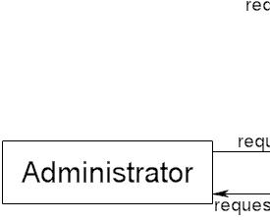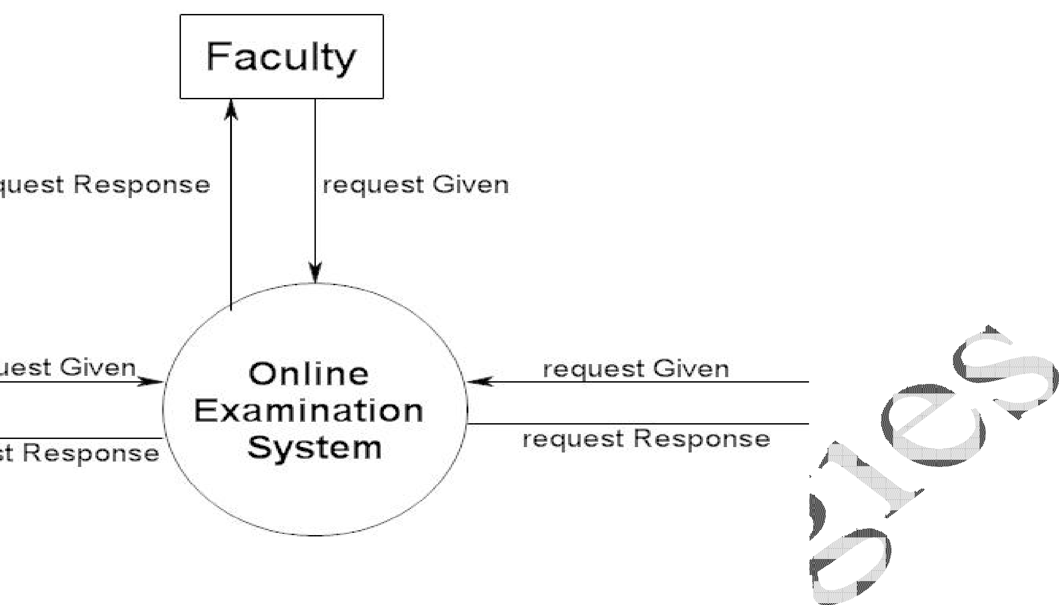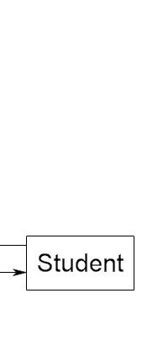

Client

Relationship

management

customer

**Fig.4 (a)” Level 0 DFD**

**+**



Customer

Customer

Admin

Database

System

Customer Review

User Manager

Customer Reports

Review viewer

**“Fig.4 (b)”: Level 1 Admin DFD**



Customer Interface

Customer Registration/Login

System Estimation Module

Self-Thought Submission

Developed System Status/Review

Deals Information Module

**“Fig.4(c)”: Level 1 Customer DFD**



Admin Interface

| ^

| |

v |

User Management Module

| ^

| |

v |

Customer Review Management

| ^

| |

v |

Customer Relationship Analysis

| ^

| |

v |

Customer-Wise Reporting Module

**“Fig.4(c)”: Level 2 Admin DFD**





Customer Interface

| | | |

System

Estimation

Authentication Module

Deals Information

| | | |

Developed System Status/Review

Self -Thought Submission

**“Fig.4(c)”: Level 2 Customer DFD**



# E-R DIAGRAM

Review

Project

Customer

Admin

Review_id

admin_id

Customer_id

Project_id

Manages provides

User

deal_id

customer_id

deal_details

thought_id

customer_id

thought_details

estimation_id

project_id

estimation_details

DealsInfo

Self-Thought

SystemEstimation

User_id

**E-r Diagram Admin & Customer**



User

|

Admin

Customer

View All Customer

Reviews

Manage User

Give self -Thought

Get System Estimation

Register & Login

Compare-Customer

Relationship

View Customer Wise Reporting

View System

Status &

Review

View Status

& Review

View Deals

Info

**Use case Diagram**



Enter Username & Password

Admin

Customer

Verify Username & Password

**Login Use Case**



# ACTIVITY DIAGRAM

Enter Username and Password

Submit Username and Password

Verify Username and Password

Valid Login

Redirect to user Home Page

**Login Activity Diagram**



Admin

Customer

|

View Customer Wise Reporting

Compare Customer Relationships

View Customer Reviews

View Deals Information

Get SystemEstimation

Manage Users

View System Review

View System Status

Provide Self Thought

Authentication

Register/Login

# 

# SEQUENCE DIAGRAM

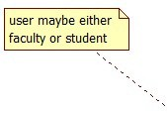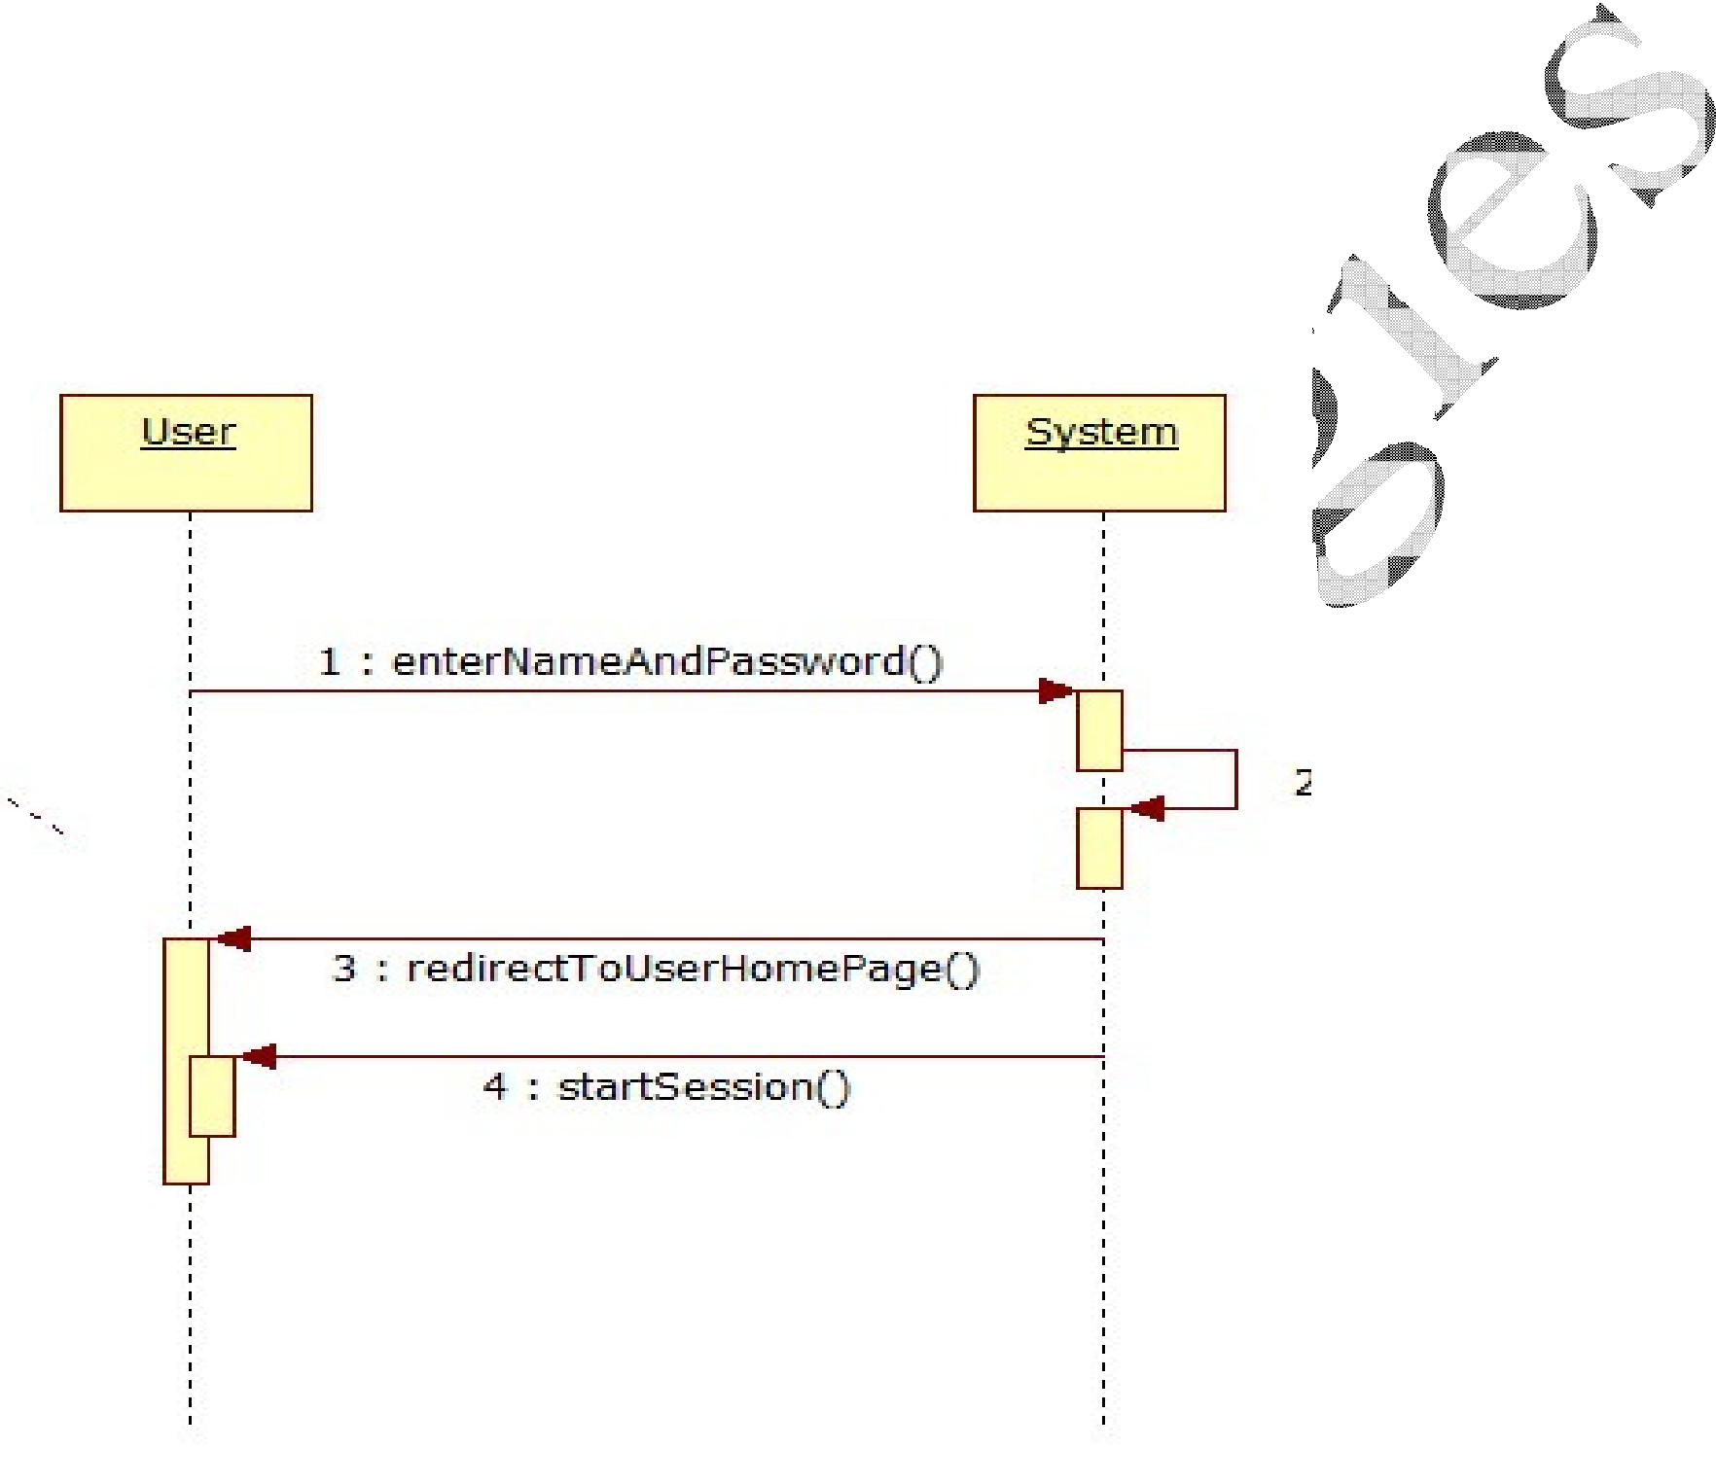

User maybe either Admin or customer



**Login Sequence Diagram**



Done Adding

Question



DATA DICTIONARY

**Table Name: Tbl_admin_reg**

|  |  |  |  |  |
| --- | --- | --- | --- | --- |
| **Field_name** | **Data types** | **Length** | **Constraints** | **Description** |
| Email | Varcchar | 30 | Not null | It’s for login as user name |
| Password | Varchar | 8 | Not Null | Login password |
| username | Varchar | 10 | Not null | First name of the administrator |
| contact | Number | 11 | Not null | Contact no of the administrator |

**Table Name: customer**

**Primary key: pk customer_id**

|  |  |  |  |  |  |
| --- | --- | --- | --- | --- | --- |
| **Field_name** | **Data types** | **Length** | | **Constraints** | **Description** |
| customer_id | Varchar | 4 | | PRIMARY_KEY | It’s for nique student id |
| username | Varchar | 8 | | Unique key | It’s for login user name |
| P password | Varchar | 8 | | Not Null | It’s for login password |
| email | Varchar | | 15 | Not null | First name of student |
| Gender | Varchar | | 15 | Not null | Last name of student |